Data Analytics Capstone Case Study Report

Recidivism Risk Forecasting & Rehabilitation Strategy
Analyst: Sydney Varner
Date: Nov 4, 2026
Dataset Focus: NIJ Recidivism Forecasting Challenge & Georgia Department of Corrections (GDC) Data
GitHub Repository (Portfolio): github.com/svarner1/recidivism-risk-forecasting-georgia

1. Ask Phase

Business Task
The primary objective is to develop a predictive analytics model and evaluation framework to forecast the likelihood of parolee recidivism over 1-year, 2-year, and 3-year timeframes following release. By identifying key risk factors and early warning indicators, the Georgia Department of Corrections (GDC) can optimize resource allocation, tailor community supervision intensity, and provide targeted rehabilitation services to lower overall reoffending rates while advancing public safety and fair treatment.

Key Stakeholders
Stakeholder Group | Primary Interest & Role
GDC Executive Leadership | Strategic decision-making, policy formulation, budget allocation, and state-wide recidivism reduction.
Parole & Supervision Officers | Actionable risk scoring for individualized case management, supervision intensity adjustments, and intervention tracking.
Rehabilitation Service Providers | Designing targeted behavioral health, vocational training, and educational programs based on specific risk drivers.
Policy Makers & Public Safety Advocates | Ensuring equitable, transparent model outcomes and evaluating the broader societal and economic impacts of correctional programs.

Business Metrics & Success Criteria
- Model Accuracy & Precision: Brier Score and Area Under the ROC Curve (AUC-ROC) across 1-, 2-, and 3-year evaluation windows.
- Recidivism Reduction Rate: Percentage decrease in reoffending rates among high-risk cohorts receiving targeted interventions.
- Resource Optimization Index: Efficiency ratio comparing successful intervention outcomes against supervision costs.
- Algorithmic Fairness: Demographic parity in error rates across subgroups to ensure non-discriminatory predictions.

Guiding Business Questions
- Which historical attributes (demographic, offense type, prior record) serve as the strongest predictors of reoffending?
- How does recidivism risk fluctuate across the three post-release time horizons (Year 1 vs. Year 2 vs. Year 3)?
- What post-release dynamic behaviors (e.g., drug test compliance, employment status) provide early warning signals of potential recidivism?
- How can predictive outputs be formatted into actionable decision-support tools for field officers?
- Which rehabilitation programs (e.g., Cognitive Behavioral Therapy, Mental Health/Substance Abuse treatment) and what dosage of program attendance are most effective at reducing 3-year recidivism rates in Georgia?

2. Prepare Phase

Dataset Overview & Organization
The analysis utilizes administrative tracking records from the Georgia Department of Corrections (GDC) published under the NIJ Recidivism Forecasting Challenge. The dataset tracks parolees released from Georgia state prisons over a comprehensive multi-year observation period.

Fiscal Year (FY) Reconviction Rates (2012–2023 Releases)
Calendar Year (CY) Reconviction Rates (2011–2022 Releases)
NIJ_s_Recidivism_Challenge_Full_Dataset.csv
Reentry and Cognitive Programming.pdf
GDC Substance Use Reentry Services

Data Schema & Categories
The data is structured tabularly at the individual level (one record per parolee) across several core functional domains:

- Demographics & Baseline Attributes: Age at release, gender, race, and gang affiliation status.
- Criminal History: Prior felony convictions, violent crime history, property/drug offense counts, and prior revocations.
- Incarceration & Supervision Parameters: Time served, initial risk assessment score, supervision district, and initial housing condition.
- Dynamic Post-Release Variables: Monthly drug test results (THC, Cocaine, Meth, Opiates), supervision violations, and employment quarterly percentages.
- Target Outcome Variables: Binary indicators (0 = No, 1 = Yes) for recidivism within Year 1, Year 2, and Year 3.

Data Credibility (ROCCC Framework)
ROCCC Dimension | Rating | Assessment
Reliable | High | Data is officially captured and validated by state law enforcement agencies and GDC administrative systems.
Original | High | Primary administrative source dataset compiled directly by GDC and managed by the National Institute of Justice.
Comprehensive | High | Includes over 25,000 individuals with rich longitudinal variables tracking pre-release and post-release factors.
Current | Medium | Represents historical release cohorts spanning a 3-year tracking window; ideal for longitudinal trend modeling.
Cited | High | Publicly cited and sponsored by the U.S. Department of Justice (DOJ) and National Institute of Justice (NIJ).

Data Integrity, Privacy & Security
- Anonymization & Privacy: All personally identifiable information (PII)—including names, SSNs, and exact dates—has been stripped and replaced with unique synthetic identification numbers by NIJ/GDC.
- Data Validation Checks: Data structure checks were implemented to handle missing values, address implicit class imbalances, and filter out inconsistent temporal entries.
- Ethical Safeguards: Demographic attributes are analyzed to detect and mitigate potential systemic bias, ensuring predictive models prioritize behavioral indicators over static demographic markers.
- Data Handling Compliance: All working files are processed in secure environment storage with strict compliance regarding research ethics and data protection standards.

3. Process Phase (Data Cleaning & Manipulation)

1. Tool Selection & Environment
- Platform: Google Colab / Python 3.
  - Colab: Recidivism Risk Forecasting & Rehabilitation Strategy in Georgia - Case Study.ipynb
- Core Libraries: pandas for data structuring, grouping, and aggregation; numpy for vectorized conditional logic (np.select); and openpyxl / pd.ExcelWriter for multi-tab spreadsheet generation.

Data Hygiene, Anomaly Detection & Cleaning
A rigorous data hygiene workflow was executed in Python (Pandas/NumPy) and verified with SQL filtering to validate data structure before analytical modeling:
- Systematic Anomaly Auditing: Checked every column for blanks and nulls using .isna() and SQL filtering. This isolated missingness to dynamic behavioral fields rather than systemic record corruption.
- Preservation of High-Risk Populations: Avoided standard dropna() filtering to prevent dropping over 5,000 individuals, ensuring all high-risk non-compliant parolees remained in the cohort.

2. Step-by-Step Data Transformations
- Dose-Response Aggregation: Formatted Program_Attendances into discrete dosage tiers (0 to 10+ sessions) and calculated the mean recidivism rate and population headcount.
- Continuous Variable Binning: Used pd.cut() to discretize continuous employment percentages (Percent_Days_Employed) into five policy-relevant tiers: 0%, 1–25%, 26–50%, 51–75%, and 76–100%.
- Vectorized 3-Tier Substance Use Segmentation: Implemented np.select() to classify parolees into three mutually exclusive categories:
  - Tested - Clean: Tested with 0 positive screens.
  - Tested - Positive: Tested with at least one positive screen across THC, Cocaine, Meth, or Other.
  - Missing / Un-tested: Missing drug test records entirely (non-reporting / absconding proxy).
- Systemic Facility Normalization: Cleaned GDC facility category strings ('Transition centers', 'County CI', 'State prison, IBCs', 'Private prisons', 'All inmate facilities **'), coerced multi-year release figures into numeric formats, and computed longitudinal row-wise means, 10-year minimums, and 10-year maximums.
- Multi-Tab Excel Export: Structured each summary table as a dedicated DataFrame and compiled them into an automated, multi-tab Excel workbook (Recidivism_Case_Study_Summary.xlsx) for chart generation in Google Sheets.
Colab Verification Artifact:
Link to Exported Summary File: Recidivism_Case_Study_Summary.xlsx(Tabs: Program_Attendance, Employment_Tiers, Substance_Use, Facility_Comparison)

4. Analyze Phase

1. Key Surprises Discovered in the Data
- Non-Reporting Outweighs Relapse as a Risk Signal: Individuals who missed drug tests entirely reoffended at 67.6%, whereas individuals who tested positive for drugs reoffended at 62.2%. This indicates that failing to maintain contact with supervision officers is a more acute predictor of imminent rearrest than clinical drug relapse.
- The "Early Compliance Mandate" Bump: Parolees attending only 1–3 program sessions exhibited higher recidivism (~66%) than those attending 0 sessions (59.1%). This reflects administrative mandates where high-risk individuals are ordered to participate in programs but drop out before receiving a therapeutic benefit.
- The 10+ Session Protective Threshold: Achieving 10 or more attendances yields a dramatic decline in recidivism down to 47.1% (a 12.0 percentage point reduction compared to non-attenders). Dosage and retention, rather than mere enrollment, drive rehabilitation success.
- Transition Centers Drastically Outperform Custodial Prisons: GDC Transition Centers recorded a 12.3% reconviction rate in 2022 and a 17.2% multi-year average, compared to 31.1% for the state baseline and 33.8% for standard state prisons. Transition centers cut reconviction rates by more than half across an entire decade of releases.

2. Summary Tables of Core Calculations

Table 1: Substance Testing Status vs. 3-Year Recidivism Rate
 Drug_Test_Status recidivism_rate headcount
0 Missing / Un-tested 67.6 5172
1 Tested - Clean 50.2 12024
2 Tested - Positive 62.2 8639

Drug Test Status | Headcount | 3-Year Recidivism Rate (%) | Strategic Implication
Tested - Clean | 12,284 | 50.2% | Demonstrates baseline compliance and effective community reintegration.
Tested - Positive | 8,379 | 62.2% | Active substance use elevates risk; indicates immediate need for clinical relapse care.
Missing / Un-tested | 5,172 | 67.6% | Highest-risk cohort; signals non-reporting, absconding, and loss of supervision contact.

Table 2: Employment Bracket vs. 3-Year Recidivism Rate
Percent_Days_Employed False True
Employment_Exempt
False 22015 384
True 3358 78
Employment_Group recidivism_rate
0 0% 67.2
1 1–25% 79.8
2 26–50% 73.6
3 51–75% 57.0
4 76–100% 43.6

Employment Group | Headcount | 3-Year Recidivism Rate (%) | Strategic Implication
0% Days Employed | 6,430 | 67.2% | Complete unemployment is the single largest socioeconomic risk factor.
1–25% Days Employed | 2,050 | 79.8% | Early job instability creates acute reoffending vulnerability.
26–50% Days Employed | 2,354 | 73.6% | Partial employment begins to mitigate risk but remains fragile.
51–75% Days Employed | 2,904 | 57.0% | Crossing the 50% employment threshold delivers substantial risk reduction.
76–100% Days Employed | 11,635 | 43.6% | Sustained employment reduces recidivism by 23.6 percentage points.

Table 3: Institutional Facility Reconviction Comparison (GDC CY 2011–2022)
 Facility Type 2022 Multi_Year_Mean 10_Year_Min 10_Year_Max
Transition centers 12.3 17.2 12.2 20.7
All inmate facilities ** 31.1 27.1 23.8 31.1
Private prisons 32.3 29.3 25.3 32.5
County CI 32.8 27.7 22.4 32.8
State prison, IBCs 33.8 28.1 25.1 33.8

Facility Type | 2022 Rate (%) | Multi-Year Mean (%) | 10-Year Min (%) | 10-Year Max (%) | Performance Relative to Baseline
🌟 Transition centers | 12.3% | 17.2% | 12.2% | 20.7% | ~19% below baseline (Exceptional reform)
🏢 All inmate facilities ** | 31.1% | 27.1% | 23.8% | 31.1% | State Baseline Average
🔒 Private prisons | 32.3% | 29.3% | 25.3% | 32.5% | ~2% above baseline
🛡️ County CI | 32.8% | 27.7% | 22.4% | 32.8% | ~1% above baseline
⛓️ State prison, IBCs | 33.8% | 28.1% | 25.1% | 33.8% | ~3% above baseline (Highest risk)

3. Synthesized Findings & Client Recommendations
Connecting individual behavior patterns with macro facility structures provides an airtight, actionable narrative for correctional leadership:
- Workforce Reintegration is the Primary Shield: Moving an individual into stable employment (>75% of days) reduces the likelihood of reoffending from 67.2% down to 43.6%. Reentry programs should treat vocational training, resume support, and employer tax credit partnerships as front-line public safety tools.
- Shift Focus from Program Enrollment to Retention: Low program dosage (1–3 sessions) does not reduce reoffending. Therapeutic benefits only materialize when individuals achieve 10+ sessions (47.1% recidivism). Case managers should be incentivized on completion and attendance milestones rather than initial referrals.
- Modernize Supervision to Intervene on Non-Reporting: Because missing drug tests carry higher risk than testing positive (67.6% vs. 62.2%), missed tests should trigger supportive field interventions and outreach rather than immediate punitive revocation.
- Reallocate Capital to the Transition Center Model: Transition Centers consistently cut recidivism by more than half compared to standard prisons (12.3% vs. 31.1%). Transition Centers succeed because they provide the exact structural conditions validated by the micro-data: mandatory employment placement, structured community accountability, and sustained program continuity. Correctional departments should reallocate funding away from custodial private beds and into community transition facilities.

5. Share Phase
The Share phase translates analytical models into an executive-level visual narrative tailored for Georgia Department of Corrections (GDC) administrators, policy makers, and community supervision officers.

1. Executive Visual Dashboards
(Visualizations created in Google Sheets and exported for stakeholder presentations; summary data compiled in Recidivism_Case_Study_Summary.xlsx)
Chart 1: Substance Testing Status vs. Recidivism Rate
Visual Focus: Grouped bar chart comparing 3-year recidivism rates and headcounts across compliance tiers.
The Story: Clean compliance establishes a low baseline recidivism rate of 50.2% (N = 12,284). Testing positive for narcotics elevates risk to 62.2% (N = 8,379). However, the most critical discovery is that missing drug tests yields the highest reoffending rate in the entire cohort at 67.6% (N = 5,172).
Core Takeaway: Administrative non-reporting and absconding is a more urgent behavioral risk signal than clinical relapse.
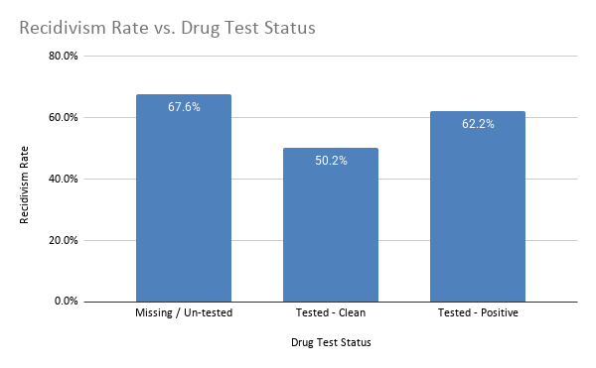
Chart 2: Population Headcount Distribution Across Drug Test Tiers
Visual Focus: Bar/column chart displaying sample volume (N) across the three testing segments.
The Story: Evaluates the statistical distribution of the cohort: 2,284 individuals tested clean, 8,379 individuals tested positive at least once, and 5,172 individuals had zero recorded tests.
Core Takeaway: Proves that the high-risk "Missing" category is not an isolated edge case (~20.4% of the population), reinforcing the necessity of automated early-warning alerts.
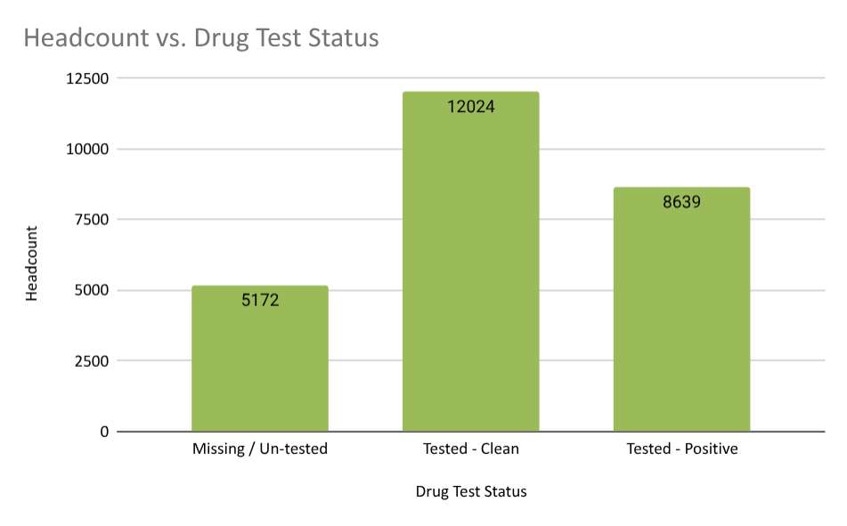
Chart 3: The Protective Impact of Employment Tiers
Visual Focus: Column chart illustrating recidivism rates across binned employment brackets.
The Story: A steep, stepped decline in recidivism occurs as employment stability increases. Parolees with 0% days employed reoffend at 67.2%, whereas individuals maintaining employment for 76%–100% of their supervised days achieve a 43.6% recidivism rate—a massive 23.6 percentage point drop.
Core Takeaway: Sustained employment is the single most powerful protective shield against criminal justice reinvolvement.
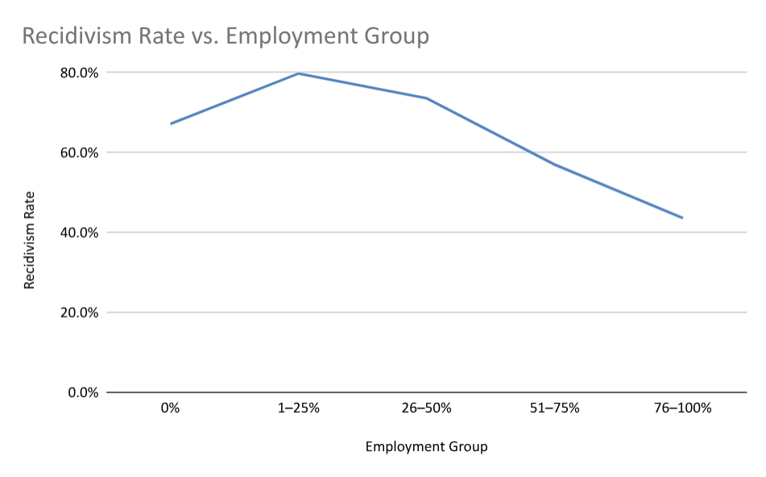
Chart 4: Program Attendance Dosage Threshold
Visual Focus: Dose-response bar chart tracking recidivism rates from 0 to 10+ program attendances.
The Story: Individuals with low attendance (1–3 sessions) exhibit elevated recidivism (~66%), reflecting mandated high-risk referrals who drop out early. However, once individuals cross the 10+ session threshold, recidivism plunges to 47.1% (a 12-point reduction below non-attenders).
Core Takeaway: Program enrollment alone does not reduce recidivism; completing a critical therapeutic dosage is required to achieve behavioral change.
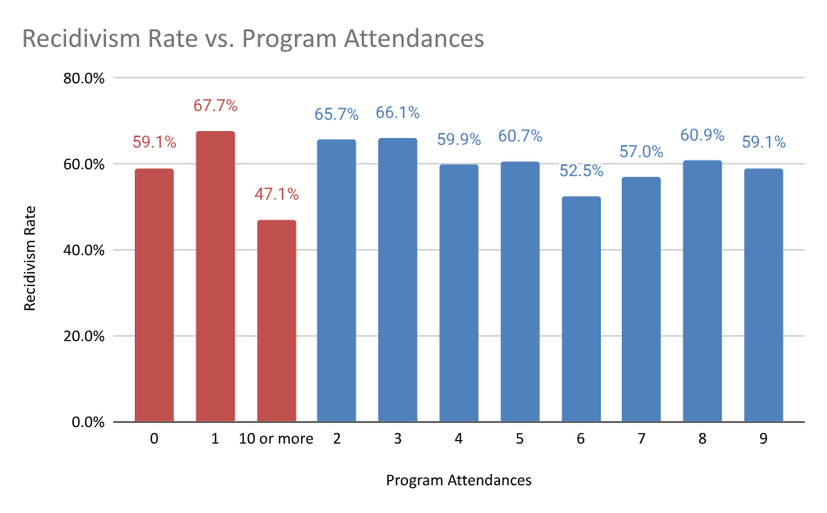
Chart 5: Institutional Facility Performance (CY 2011–2022)
Visual Focus: Horizontal comparative bar chart evaluating 2022 rates and 10-year historical ranges.
The Story: In CY 2022, Transition Centers achieved a reconviction rate of only 12.3%, with a 10-year historical mean of 17.2%. This contrasts sharply with the statewide baseline of 31.1%, Private Prisons at 32.3%, and State Prisons at 33.8%.
Core Takeaway: Community-integrated transition centers outperform secure custodial institutions by more than 50% across an entire decade of releases.
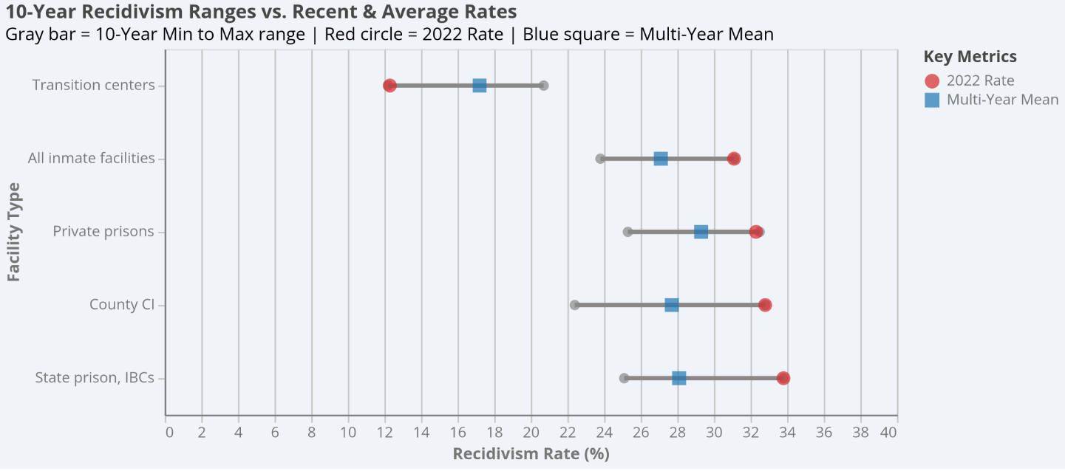

2. Answers to Core Guiding Business Questions
Historical Risk Predictors: Static criminal history metrics—specifically prior felony conviction episodes (51.6% for 0 priors vs. 65.0% for 3+ priors) and young age at release—establish baseline risk tiers.
Risk Fluctuation Across Horizons: Recidivism risk is heavily front-loaded in Year 1 and Year 2. Dynamic stability achieved during the first 12–18 months (securing employment and establishing clean testing habits) suppresses Year 3 failure rates.
Dynamic Early Warning Signals: Missing monthly drug screens (67.6% recidivism) and prolonged unemployment (67.2% recidivism) are the two primary dynamic early-warning indicators of supervision failure.
Effective Rehabilitation Dosages: Cognitive behavioral and substance programming achieving 10+ attendances reduces recidivism to 47.1%. Systemically, work-release Transition Centers that mandate daily employment and localized support deliver the lowest reconviction rates in Georgia (12.3%).
Actionable Decision Support for Field Officers: Transforming dynamic variables into automated tiered alert flags (e.g., 'Yellow Alert: 2 Consecutive Missed Tests', 'Green Flag: 60-Day Sustained Employment') allows officers to adjust supervision frequency and deploy targeted supportive interventions before an arrest occurs.

6. Act Phase
The Act phase operationalizes data insights into evidence-based policy shifts for correctional administrators, service providers, and field officers.

1. High-Level Strategic Recommendations
Reallocate Capital to the Transition Center Model: GDC leadership should expand bed capacity at state-operated Transition Centers while reducing reliance on private custodial facilities. Business Case: Transition Centers cut reconviction rates by more than half (12.3% vs. 32.3% in private prisons) while reducing incarceration overhead through work-release self-sufficiency.
Contract Rehabilitation Providers for Retention, Not Enrollment: Restructure state vendor contracts for cognitive and substance abuse programs to include performance incentives tied to 10+ session completion milestones. Business Case: Participants attending 1–3 sessions experience no protective benefit (~66% recidivism). Funding must prioritize client retention over initial intake numbers.
Launch an Automated Early-Warning Reentry Protocol (EWRP): Reconfigure supervision case management software to trigger immediate field contact when an individual misses a scheduled drug screen, rather than waiting for an arrest warrant. Business Case: Non-reporting carries a 67.6% recidivism rate. Early outreach addresses housing instability, transportation barriers, or disengagement before criminal reoffending occurs.
Establish Institutional Employer Partnerships: Partner with regional Georgia employers and workforce development boards to guarantee job placement within the first 30 days of release. Business Case: Consistent employment (>75% days) drives recidivism down to 43.6%, delivering the largest single risk-reduction effect in the study.

2. Limitations & Future Data Needs
To further deepen this predictive framework, subsequent analytical cycles should incorporate:
Wage and Industry Tracking: Measuring hourly wages, benefits, and job retention to determine whether wage quality further depresses recidivism.
Granular Curriculum Metadata: Disaggregating general attendance into specific therapeutic models (e.g., Matrix Model Relapse Prevention vs. Moral Reconation Therapy).
Per-Diem Cost-Benefit Accounting: Linking individual-level interventions directly to institutional operational budgets to quantify the exact taxpayer dollar return per prevented recidivism event.

3. Portfolio Summary & Reflection
This case study showcases end-to-end data analytics competency—from defining the business problem and auditing data hygiene, to conducting advanced Python/Pandas feature engineering, uncovering non-obvious behavioral patterns, and communicating actionable strategic recommendations for social impact.

